Archimate Extractor in Pega

By using this in the application we can get the application details such as below

The extractor will go through the application and its configuration and extract the following information and create views:

* Case types
  + Stages
  + Processes
  + Roles
  + Data Objects
* Data Objects
  + Relations
* Channels
* Application stack

And now the XML file can be viewed by clicking on Application > Documentation

Then we can view the XML document in the edge or chrome browser

The following are some of the references

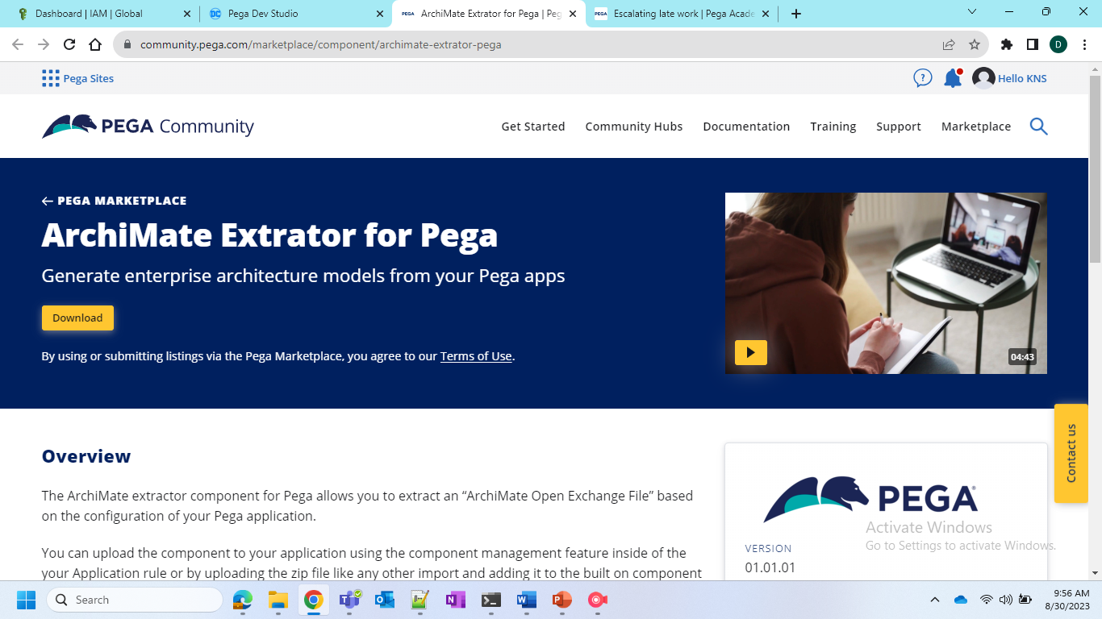

After the Generation it would be very useful

